🔍 Abstract:

This project focuses on building a smart energy consumption monitoring and prediction system using IoT and Machine Learning. By collecting real-time energy usage data via smart meters connected to a microcontroller (like NodeMCU), the data is sent to a cloud database. A machine learning model analyzes historical usage patterns to forecast future energy consumption and visualize it on a web dashboard.

---

⚙ Hardware Requirements:

1. NodeMCU (ESP8266/ESP32) – for WiFi connectivity.
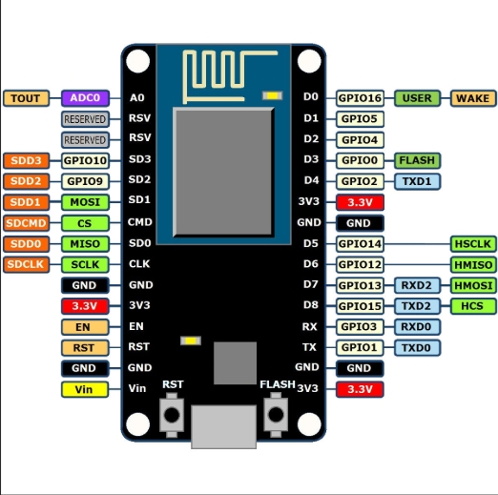
2. Current Sensor (e.g., ACS712) – to measure real-time current.
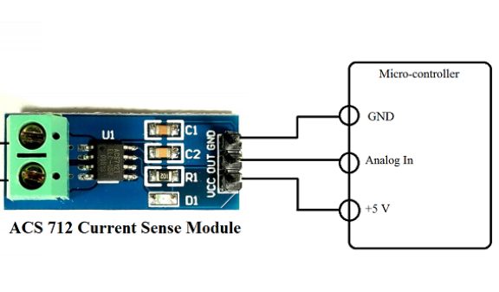

3. Voltage Sensor (ZMPT101B) – for voltage monitoring.
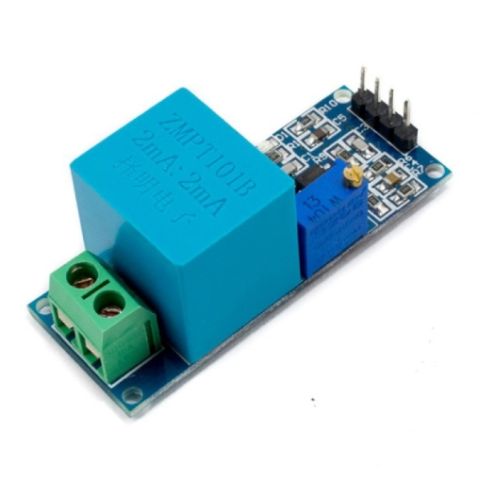

4. Smart Energy Meter (optional integration)
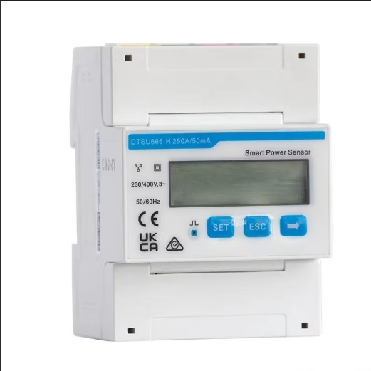

5. Resistors, Breadboard, Jumper Wires

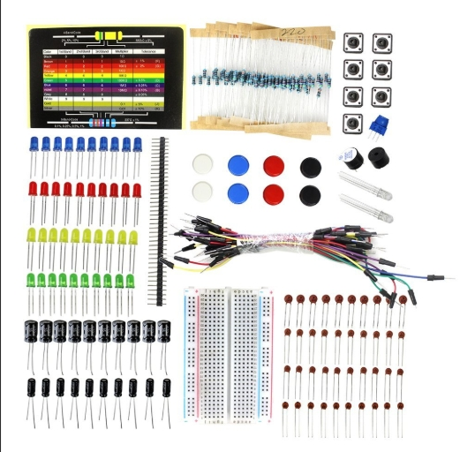
6. Power Supply (5V/9V)

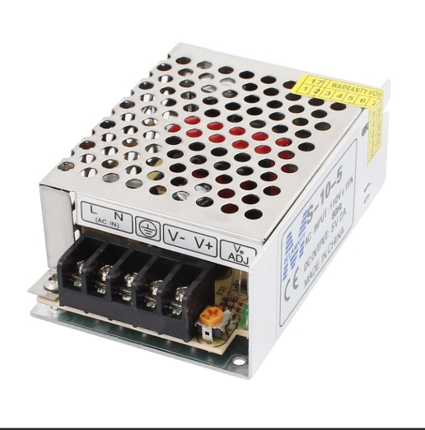
7. USB Cable (for programming NodeMCU)
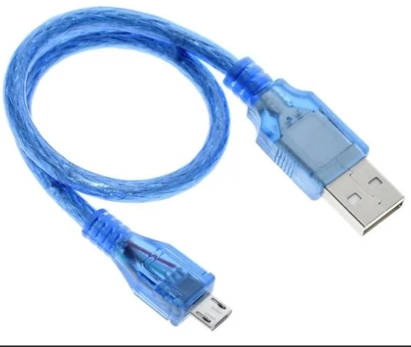

💻 Software Requirements:

1. Arduino IDE – to code and flash NodeMCU

2. Python – backend logic, ML model training

3. Flask or FastAPI – for API backend

4. MongoDB / Firebase – for storing sensor data

5. Pandas, NumPy, Scikit-learn – for ML model

6. Matplotlib / Plotly – data visualization

7. HTML, CSS, JavaScript – for frontend dashboard

8. Chart.js / D3.js – dynamic visual charts

---

🧠 Machine Learning Workflow:

1. Data Collection: Energy consumption data (voltage × current × time)

2. Preprocessing: Time-series formatting, normalization

3. Model Used: Linear Regression or LSTM (for time series)

4. Training Dataset: Historical sensor readings

5. Prediction Output: Estimated future usage (kWh)

6. Performance Metrics: MAE, RMSE

---

📊 Features:

Real-time voltage, current, power consumption display

Daily/weekly/monthly energy usage charts

Forecast of future usage based on historical data

Cloud-stored logs for analysis

Alert generation when consumption crosses thresholds

---

📈 Workflow Diagram (Text Form):

Sensors → NodeMCU → Wi-Fi → Cloud Database → Backend API → ML Model → Dashboard
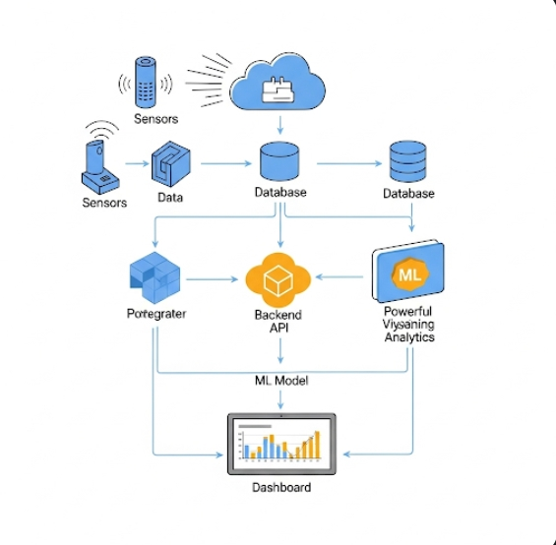

🔄 System Flow:

1. Hardware Layer:

Sensors measure voltage & current → send to NodeMCU

2. IoT Layer:

NodeMCU sends data every few seconds via WiFi to backend server

3. Backend Layer:

Python/Flask receives data → stores in MongoDB

ML model reads from MongoDB → forecasts consumption

4. Frontend Layer:

User dashboard fetches data from API

Graphs & alerts shown using Chart.js or D3.js

---

🛡 Advantages:

Promotes energy conservation

Smart bill forecasting

Alerts for abnormal energy usage

Scalable for home, office, or industries

---

🧾 Future Scope:

Add solar energy usage tracking

Integrate billing API from energy providers

Add user-based analytics (e.g., peak usage hours)

App integration (Android/iOS)

📂 File Structure:

/iot-energy-predictor
├── backend/
│ ├── app.py (Flask server)
│ ├── model.pkl (trained ML model)
│ └── db.py (MongoDB functions)
├── frontend/
│ ├── index.html
│ ├── script.js
│ └── styles.css
├── iot/
│ └── energy_sensor.ino (Arduino code for NodeMCU)
├── dataset/
│ └── energy_data.csv

